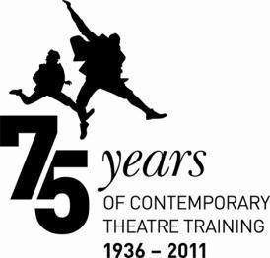

MA/PGDip PROFESSIONAL VOICE PRACTICE – AUDITION GUIDANCE

Auditioning/interviewing in person at Birmingham Conservatoire Acting
We recognise that you will inevitably be nervous about your audition and interview; much rides upon the outcome. We work hard to ensure that your audition and interview are positive experiences. Members of both academic and admissions staff will be available to answer questions at all stages.

If you wish us to take dyslexia or dyspraxia into account at your audition and interview you must bring with you a copy of your assessment/report confirming the condition and hand it to the Admissions Officer.

PUNCTUALITY
You should make sure you arrive in plenty of time for your audition; if for any reason you will be late please let us know. Punctuality is essential during the course, as it is when working in the profession. We are aware that sometimes transport is delayed – however, we will expect you to have arranged your travel to arrive on time even if there is a reasonable delay.

Please note: Street shoes and stilettos are not allowed in any of our studios, but jazz and character shoes are.

SPEECHES AND FEEDBACK
You will be asked to present a prepared programme to a panel of staff, which will include the Course Director and/or another member of the Voice team. You have up to ten minutes in which to present your prepared programme and this will be followed by a discussion with the panel who will provide verbal feedback on what you present, discuss your choice of material and your motives for applying to the MA Professional Voice Practice programme.

You must prepare and present:
- a speech in verse from an Elizabethan/Jacobean play OR a musical theatre song (with
accompaniment)
- a Shakespeare sonnet
- a piece of modern or contemporary verse

Your programme should last at least five minutes.

Please note: If you plan to perform a song as part of your audition, you must let us know when you accept your invitation to audition so that we can arrange an accompanist.

You should have read the whole of the play from which any speech is taken and be able to provide the correct title, name of the author if relevant and translator. You may be asked questions about the play and your character’s journey within it (i.e. their motives etc.). It is not advised that you attempt an accent unless you are entirely confident of its accuracy and only if it is appropriate to the speech.

Any performance choices you make should be justifiable within the text. The performance should reveal an understanding of the scene and character and/or the demands of the text. Try to make sure that any vocal and physical interpretation you do is strictly relevant.

Although candidates may not be from an acting or performance background, you need to be able to demonstrate some sensitivity to and awareness of the demands of speaking text in a performance context.

THE SONG
Should you choose to perform a song, your song should be a published work with piano accompaniment. We will provide a pianist but you must provide sheet music in a suitable format for the pianist to use.

We are interested to see how you interpret a song and its content. We appreciate that some candidates are not experienced singers but we do not believe that this stops anyone from expressing the style and content of a song. It is important that you choose a song suitable for your voice, gender and age.

Your Interview
You will be interviewed by the Course Director or his/her representative to gain a better understanding of you and your motives for wishing to pursue the MA Professional Voice programme. As well as discussing your audition choices and your reasons for wishing to become a voice practitioner, you can expect to be asked about any previous experience you may have within the voice field and what your research interests may be. These do not, by any means, have to be fully formed ideas but there is a research element to the course so it is important to consider at this stage what area of voice practice you might wish to explore in greater depth.

If you wish to be considered for the PGDip Professional Voice Practice course you do not need to concern yourself with the research element.

Auditioning via DVD
If you live outside the UK/EU you can undertake an initial audition via multi-regional format DVD. You should present your speeches (and song, if included) in English to camera and perform them as you would in a live audition, using the guidelines above.

Please ensure that we can see the whole of your body – it is not necessary to provide close-ups or produce an edited piece of television, but you should ensure that the sound quality is sufficient for us to make an accurate assessment of your voice. You should supply the title, author and, if relevant, translator details with your speeches.

You may also make a short statement of no more than three minutes about the pieces – a brief résumé of the plays, characters and chosen texts/song.

You may also include a brief statement in support of your application. Please ensure that you write your name and the course applied for on your DVD.

What happens next?

DECISION ON AUDITION
The staff on the panel – guided by the Course Director – make the decision whether to offer a place. Within 10 working days of your Audition you should receive confirmation by email of the result. If you have not heard within 21 days please contact bsaadmissions@bcu.ac.uk. Decisions for international students applying via video/DVD may take longer, but you should hear within 30 days of our receipt of your audition.

OFFER OF A PLACE
Following an audition and/or interview, one of the following outcomes is possible:

- You are offered an unconditional place
This means that you have a place on the course for which you applied. This offer is only for the year in which you apply.
- You are offered a conditional place
This means that you will have a place on the course for which you applied if you attain the required academic qualifications. This offer is only for the year in which you apply.
- You are offered a reserve place on the course.
This is the most common outcome. It indicates that you have reached an acceptable standard, but because applications and auditions/interviews happen throughout the year we cannot allocate all places on a course until the auditions/interviews have been completed.
- You are not offered a place on the course

You cannot re-apply for a place on the same course in the same academic year.

APPEALING AGAINST AN UNSUCCESSFUL AUDITION
If you wish to appeal against a decision you should contact the Admissions team at admissions@bcu.ac.uk, within 14 days of notification to receive a copy of the Appeals Policy. An appeals panel, led by a senior member of staff who was not involved in your audition, will investigate thoroughly any grounds for appeal and will notify you of the outcome.

Directions to Birmingham Conservatoire Acting at Millennium Point by Road
Millennium Point is clearly signposted from all main routes into the city – simply follow the brown tourist signs. Currently, there are major road works in the vicinity of Millennium Point and access routes may change on a regular basis. You may need to follow diversion routes where indicated.

From M6, Junction 6 (Aston Expressway)
Follow signs to City Centre on the A38(M). After the first exit follow signs for Ring Road and Convention Centre. You immediately come to Dartmouth Circus roundabout. Take the first exit (Dartmouth Middleway, A4540). At the next roundabout take the third exit onto Jennens Road.

From M5, Junction 3 (Hagley Road)
Follow the A456 into Birmingham for approximately 6 miles, through the tunnel at Five Ways, onto Broad Street.
Follow signs for the A38 (Aston Expressway) onto Great Charles Queensway. Proceed under the tunnel at St Chad's Queensway. Indicate left as you exit and go down to the island at the bottom.
Take the third exit onto James Watt Queensway. Continue onto Chapel Street, then turn left at the traffic lights onto Jennens Road. Go all the way round the next roundabout to return along Jennens Road

From M42, Junction 6 (Coventry Road)
Follow A45 City Centre for approximately 7 miles. You will then reach a large traffic roundabout (Bordesley Circus). Follow signs for the M6 into Watery Lane Middleway. At the first roundabout, follow signs for the M6. At the second roundabout, take the second exit into Lawley Middleway. At the third roundabout (Ashted Circus) take the first left onto Jennens Road.

Car Parking at Millennium Point
There is a multi-storey car park owned and managed by Birmingham City Council situated adjacent to Millennium Point. The car park entrance is on Howe Street off Jennens Road. If you are using a sat nav please use the postcode B4 7AP.

Charges at the time of writing are:
Up to 1hr - £1.50 | Up to 3hrs - £3.70 | Up to 6hrs - £5.00
Up to 2hrs - £2.80 | Up to 4hrs - £4.50 | Over 6hrs (up to 24hrs) - £6.00

Please retain your entry ticket on entering the Car Park. Payment is via machines located inside the car park building at the end of your visit. This car park accepts cash and card payments.

Walking from Birmingham New Street Station or Birmingham Moor Street Station
If you have arrived into Birmingham New Street, leave the station via the main entrance, exit to the left of the escalators and follow the path around to the Rotunda building and continue following the signs for Moor St Station. Moor Street Station is situated on Moor Street Ringway. (If you have arrived into Birmingham Moor Street, turn right out of the station and continue as follows.) Walk along Moor Street Ringway over the set of traffic lights; Birmingham Metropolitan College-Mathew Boulton Campus is on your left. After the traffic lights

Moor Street Ringway becomes Jennens Road. Walk a further 400m and Millennium Point is located on your right.

Other directions, including directions from buses etc, are available on the millennium point website
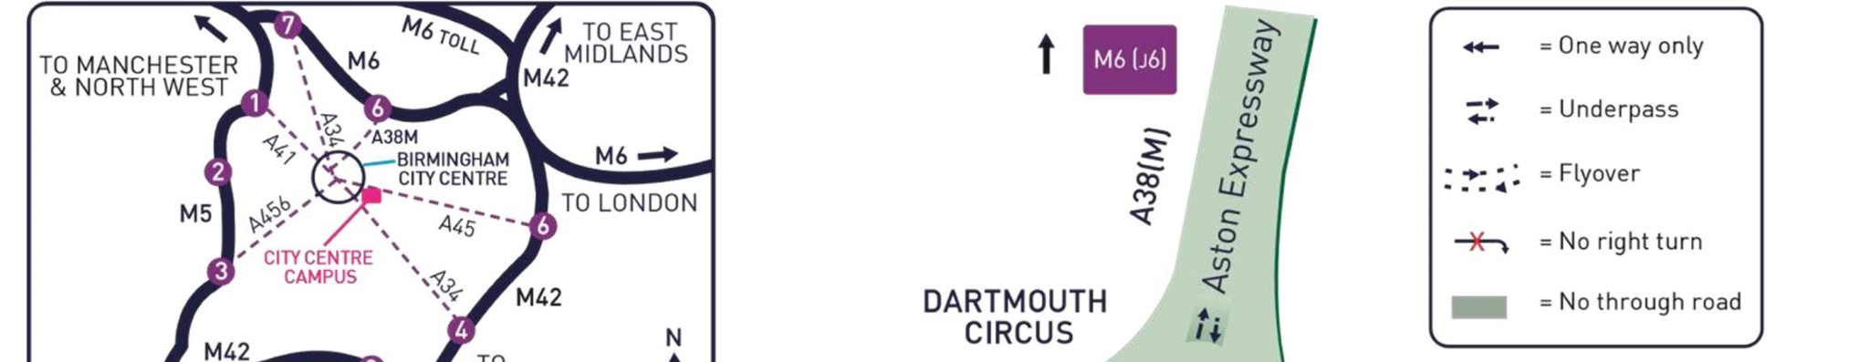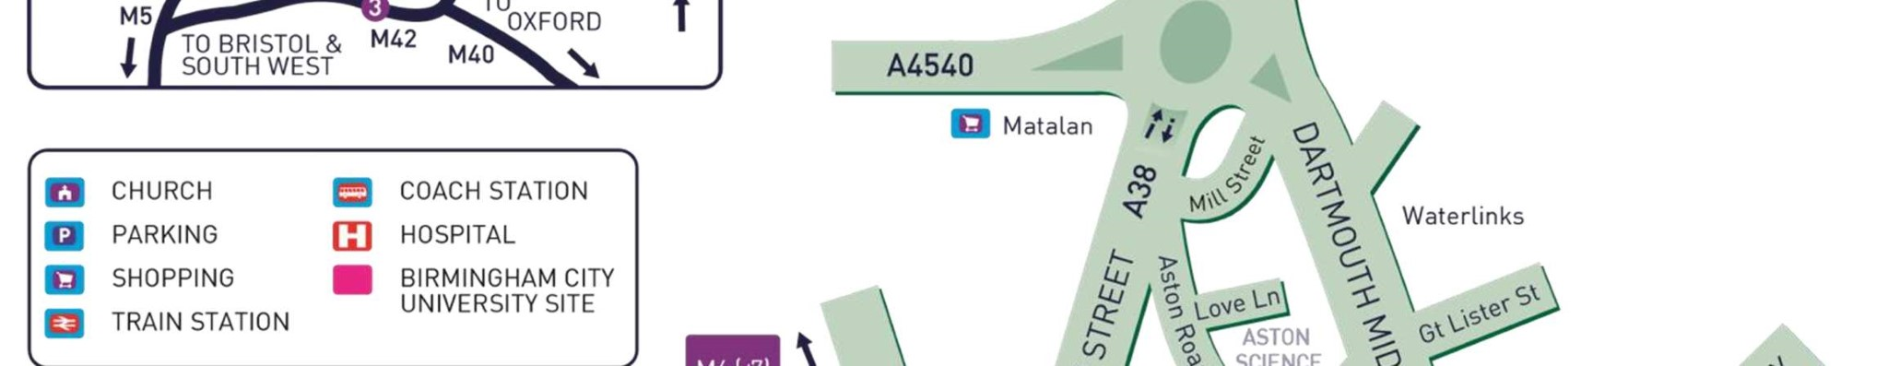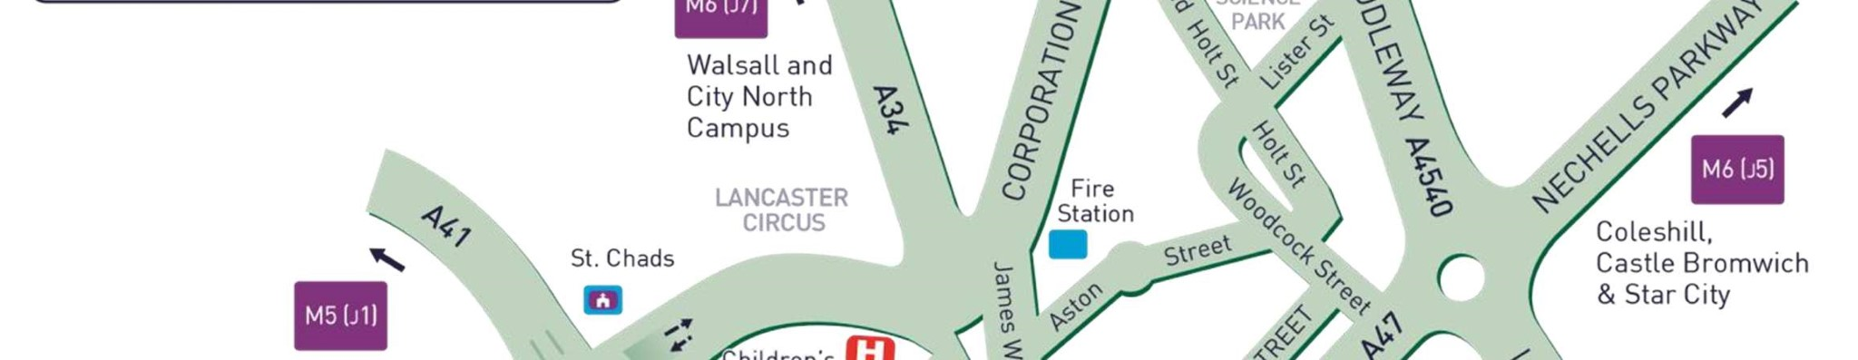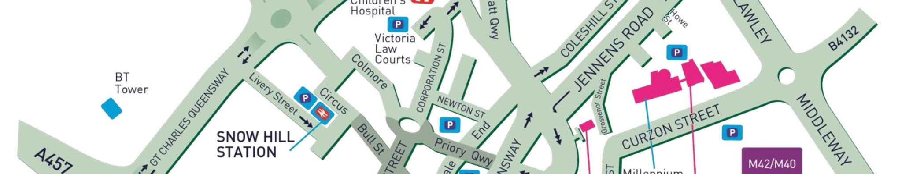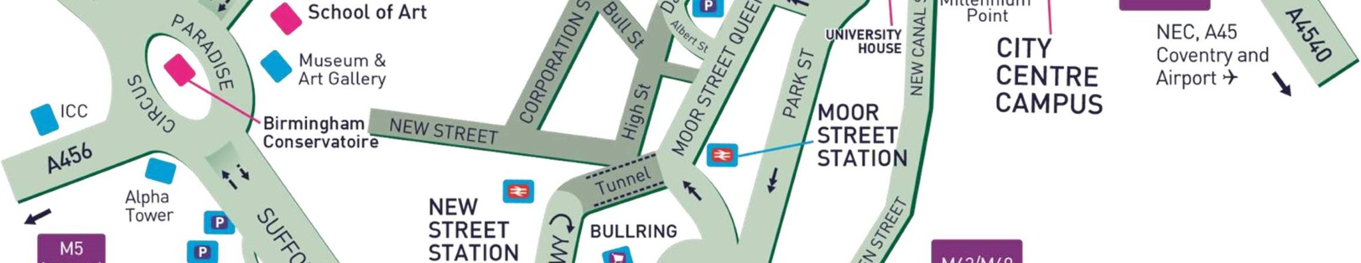

City Centre Campus
Millennium Point,
Curzon Street
Birmingham
B4 7XG
T: 0121 331 5000 W: www.bcu.ac.uk

