1. The Review process
You will be provided with no more than three applications to review and be allocated to a Panel; for D3, this will be with two colleagues, although others may participate for quality assurance purposes.
You should firstly independently assess the application, considering the Areas of Activity, Core Knowledge and Professional Values, as appropriate for this category, as set out overleaf and considering the guidance below. Using the Review form, select Award, Award Pending Condition (APC) or Refer for each Descriptor and, considering all of the Descriptors together, select an overall decision. You may also wish to make your own notes on why you have reached this decision, to discuss with Panel members.
One colleague will act as Lead Reviewer for the Panel and is responsible for arranging and facilitating any discussions about the application (face-to-face, email, phone-call). The Panel should agree an overall decision; if the Panel is unable to agree a decision, the Lead Reviewer will raise this with EDS, stating the area(s) of concern. The Convenor will discuss the application with EDS colleagues, reach a decision and advise the Panel of this. The Lead Reviewer will complete and return the Panel’s completed Review form to EDS, by the required date, and this should include any comments/feedback for the candidate that the Panel have agreed on.
Whether as a Lead reviewer or Panel member, your feedback on the review process, the overall standard of applications or any suggestions for enhancement to the PSF scheme is always welcome and will be taken forward to our Advisory Board, which meets twice each year. You may pass any comments to the Lead Reviewer, who can return with the completed Review forms, or do contact us directly at psf@bcu.ac.uk. If you would like to attend the Advisory Board, do let us know. It would be useful if you could highlight any application, or part of an application, that is seen as excellent, in order that we can liaise with the applicant for potential future use of their application as an example for colleagues.
EDS will advise candidates of the Panel’s decision and attach the completed Review form. If the decision is APC, the applicant will be advised to review the dimension(s) judged as requiring more evidence to achieve Award and to prepare for a professional dialogue with one or more Panel members; the Panel may agree that this can be conducted by one Panel member only. It is the candidate’s responsibility to contact the Panel Lead to arrange a date for this dialogue, to allow the Panel to return their decision by the agreed APC date.
In the case of both Refer and APC, candidates are advised to contact their Faculty/School Lead (Fellowship) for advice, although EDS may contact one of more Panel members to clarify any feedback on the Review form, should the candidate request this.

2. Reviewing applications
The heart of the judgement process is to use the APP to make a judgement about the actual teaching and learning support practice of the candidate. The case studies and Account of Professional Practice (APP) should summarise the candidate’s practice and be judged holistically.
Candidates should be able to provide evidence of fulfilling the requirements of ALL UKPSF Descriptors for D3:
I. Successful engagement across all five Areas of Activity
II. Appropriate knowledge and understanding across all aspects of Core Knowledge
III. A commitment to all the Professional Values
IV. Successful engagement in appropriate teaching practices related to the Areas of Activity
V. Successful incorporation of subject and pedagogic research and/or scholarship within the above activities, as part of an integrated approach to academic practice
VI. Successful engagement in continuing professional development in relation to teaching, learning, assessment, and, where appropriate, related academic or professional practices
VII. Successful coordination, support, supervision, management and/or mentoring of others (whether individuals and/or teams) in relation to teaching and learning

Making your judgement – considering the Dimensions
D3.I Successful engagement with all five areas of Activity, D3.IV Successful engagement in appropriate teaching practices related to the Areas of Activity:
D3.I and 3.IV are closely linked and are considered together. Applications should provide evidence of successful engagement with all five Areas of Activity. The evidence should be found across both the case studies and the reflective account of practice and will give descriptions of specific examples of when candidates have engaged with the Areas of Activity. It is important that the candidate clearly indicates their role in relation to the examples given and the impact and influence of their work on others. For instance, if they reflect on their education, training, employment and roles they should explain what their contribution was in each of these.
The depth of coverage of the Descriptors will vary according to the particular context and role of the candidate – the reflective account of practice and case studies do not necessarily have to be of the same length.
If you ‘refer’ any of the following then this is an automatic referral for Senior Fellowship:
• any Area of Activity
• the descriptor relating to Professional Values
• any of the descriptors relating to Core Knowledge
• the descriptor relating to the whole claim (D3.VII)
The evidence for successful engagement with D3 should be reflective and this should be based directly on all the Dimensions of Framework - that is, on the Areas of Activity, Core Knowledge and Professional Values.
D3.II Appropriate knowledge and understanding across all aspects of Core Knowledge, D3.V Successful incorporation of subject and pedagogic research and/or scholarship within activities, as part of an integrated approach to academic practice, D3.VI Successful engagement in continuing professional development in relation to teaching, learning, assessment, scholarship and, where appropriate, related professional practices:
D3.II, D3.V and D3.VI are closely linked and are treated together and evidence of fulfilling these Descriptors may be found in all sections of the APP.
D3.II The chosen examples of engagement must be accompanied by a discussion of the rationale of the candidate’s approach in terms of their acquisition and application of Core Knowledge. You are expected to use your professional judgement in relation to the overall depth and adequacy of coverage of each element of Core Knowledge. If some elements are dealt with in more depth and others more superficially then compensation is acceptable. The term ‘appropriate’ should also be used to inform your judgement about evidence of Core Knowledge. All the elements should be interpreted in the light of the professional context of the applicant and what is appropriate for them given that context. For example, the methods they choose to evaluate the effectiveness of teaching will be heavily dependent on the disciplinary and situational context in which they are teaching and/or supporting learning.
D3.V It is essential that Senior Fellows provide evidence of having accessed and utilised external advice and guidance based on educational scholarship and likely that they themselves will be undertaking some kind of research which may well (though this is not essential) include research for publication in peer review journals.
D3.VI A real and practical commitment to CPD is central to the Framework and no candidate should gain Senior Fellowship who has not clearly and explicitly evidenced such a commitment. This emphasis is stated explicitly in the Framework in A5, but is also reaffirmed in K5, K6 and V3.
D3.VII Successful coordination, support, supervision, management and/or mentoring of others (whether individuals and/or teams) in relation to teaching and learning:
This is the overarching element of the descriptor and evidence for this should be found across the application. It is the essential distinguishing characteristic of the Senior Fellow.
Completing the Review form
Insert the candidate’s name, the names of all Panel members and date the decision was agreed.

For ‘Overall decision’ insert Award, APC or Refer, as appropriate:
Award: all criteria have been met; comment if there are substantial strengths which it would be good to share with the applicant
APC: one or more Dimensions require clarification before a final decision can be made. The candidate will be invited to consider Reviewers’ feedback and prepare to justify how they have met the requirements of the Dimension(s). This process is carried out via dialogue with one or more members of the Panel and lasts no longer than 20 minutes. It is the candidate’s responsibility to contact the Lead reviewer to arrange this dialogue and the EDS will advise the date by which the dialogue should take place. The Lead Reviewer should advise EDS of the final decision, no later than one week of the dialogue taking place.
Refer: one or more Dimensions were insufficiently covered. The candidate will be directed to use Reviewers’ feedback in preparing for a re-submission and should therefore indicate what the applicant needs to do to achieve Award.

Please label the Review form ‘NAME_CATEGORY_DECISION’ e.g. ‘SMITH_D3_REFER’ and return the form to psf@bcu.ac.uk, by the agreed date.

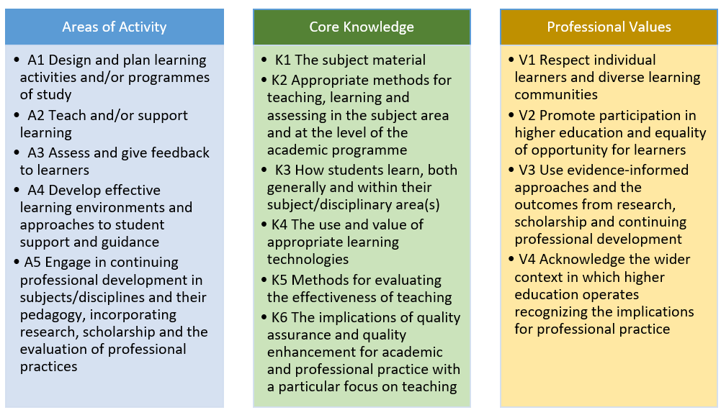

All Areas of Activity, Core Knowledge and Professional Values must be evident. | Some reviewers find it helpful to use this as a ‘marking grid’, for or their notes, to support the Panel discussion. This is optional, for your own use only – there is no requirement to complete this.
Areas of Activity
A1 Design and plan learning activities and/or programmes of study
A2 Teach and/or support learning
A3 Assess and give feedback to learners
A4 Develop effective learning environments and approaches to student support and guidance
A5 Engage in continuing professional development in subjects/disciplines and their pedagogy, incorporating research, scholarship and the evaluation of professional practices
Core Knowledge
K1 The subject material
K2 Appropriate methods for teaching, learning and assessing in the subject area and at the level of the academic programme
K3 How students learn, both generally and within their subject/disciplinary area(s)
K4 The use and value of appropriate learning technologies
K5 Methods for evaluating the effectiveness of teaching
K6 The implications of quality assurance and quality enhancement for academic and professional practice with a particular focus on teaching
Professional Values
V1 Respect individual learners and diverse learning communities
V2 Promote participation in higher education and equality of opportunity for learners
V3 Use evidence-informed approaches and the outcomes from research, scholarship and continuing professional development
V4 Acknowledge the wider context in which higher education operates recognising the implications for professional practice

